1. 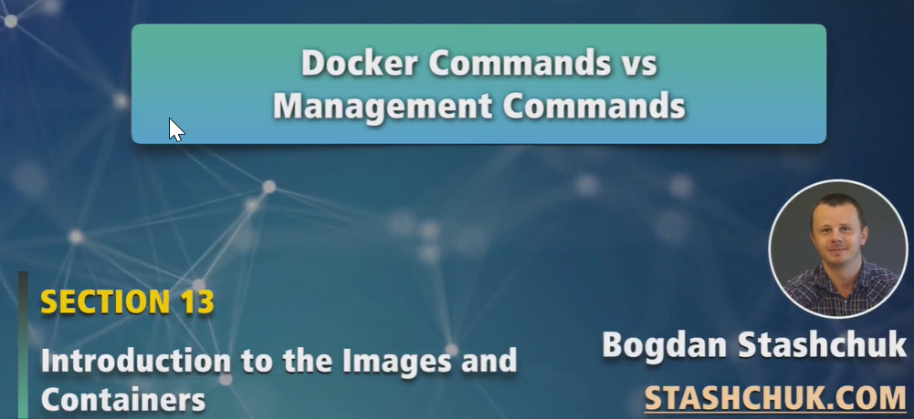
2. 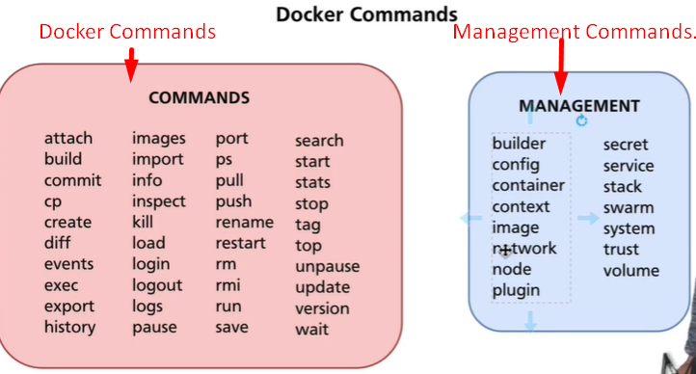
3. There are two different blocks of commands 🡺 Commands and Management Commands.
4. Historically before, in Docker, there were only commands.
5. As the list grew with commands, Docker developers decided to split those commands into two categories.
   1. **Docker Commands**
   2. **Management Commands**: Management commands need additional commands as arguments.
6. 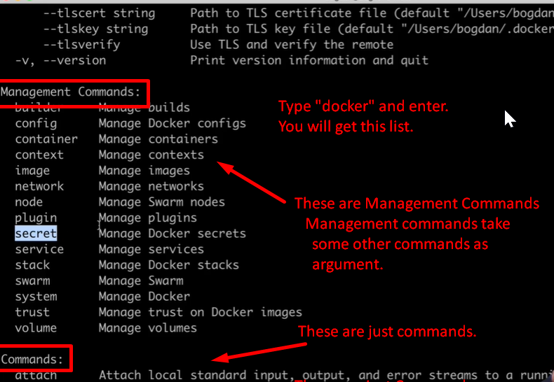
7. 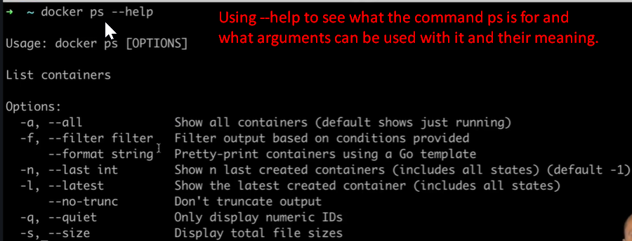

**NOTE**: The above command is not management command.

**Let’s see the** --help with management command.

1. 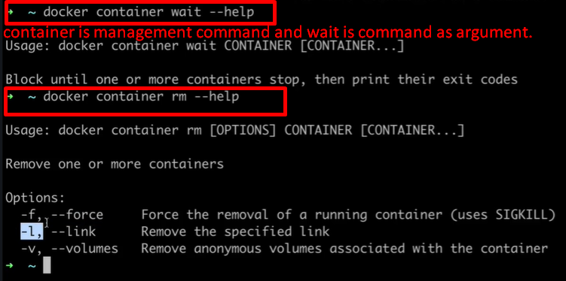
2. **NOTE**: Some commands are redundant in Docker management commands.